实验目的：

* **掌握C++语言多态性的基本概念**
* **掌握运算符重载函数的声明和定义方法**

实验内容：

* **尝试编写一个程序，实现两个复数的乘法**

#include<iostream>

using namespace std;

class Complex{

public:

double real;

double imag;

Complex(double r =0,double i=0)

{

real=r; imag=i;

}

};

Complex operator+(Complex co1,Complex co2)

{

Complex temp;

temp.real = co1.real + co2.real;

temp.imag = co1.imag + co2.imag;

return temp;

}

int main()

{

double a, b, c, d;

cin >> a >> b >> c >> d;

Complex com1(a,b),com2(c,d),total1,total2;

total1 = operator+(com1,com2);

cout<<"real1="<<total1.real<<" "<<"imag1="<<total1.imag<<endl;

total2 = com1 + com2;

cout<<"real2="<<total2.real<<" "<<"imag2="<<total2.imag<<endl;

return 0;

}

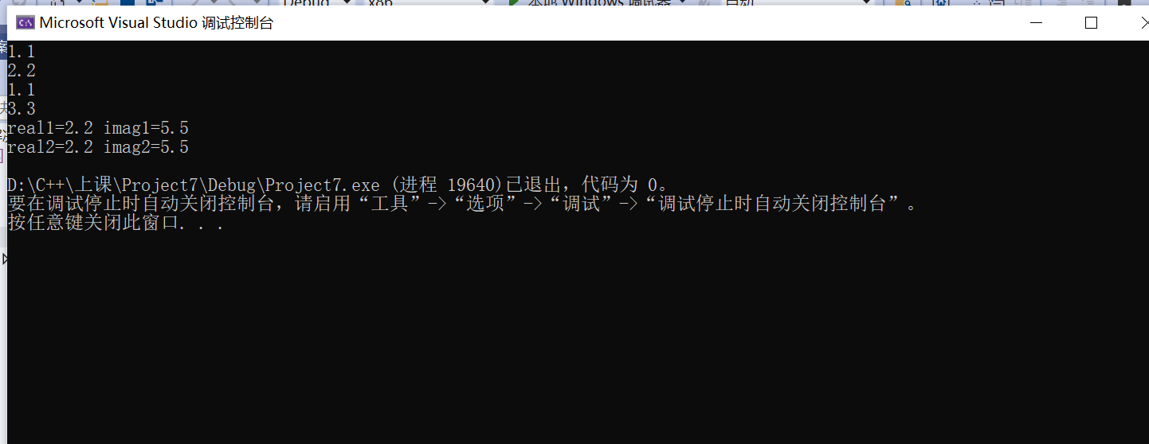

感想：

本次实验是继hollow world 最简单的，课本也又详尽的程序，初步体会多态的概念和应用。

Copyright ©2021-2099 Chen Yilu. All rights reserved